Problem Set 1
  - Steady-State Flow with Constant Head Boundaries

Introduction
The flow system is in a valley which is 10,000 ft wide and 10,500 feet long. There is an unconfined upper sand aquifer and a lower sand aquifer which are separated by a fine-grained silt that acts as a confining layer for the lower aquifer. The flow system is bounded on all sides and its bottom by impermeable bedrock. At the eastern boundary there is a river, with a stage or 320 ft, which flows south. On the western boundary there is a canal, with a stage of 330 ft.

In the upper aquifer, the horizontal conductivity in both the x and y directions is 50 ft/d, the vertical conductivity is 10 ft/d. The bottom of the upper aquifer is at an elevation of 220 ft. The top is at land surface, which can be specified as 400 ft.

In the silt unit, the horizontal and vertical conductivity is 0.01 ft/d. The bottom of the silt layer is at 200 ft.

In the lower aquifer the horizontal conductivity in both the x and y directions is 200 ft/d, the vertical conductivity is 20 ft/d. The bottom of the lower layer is at 0 ft.

Simulate groundwater flow as a steady-state flow system. Use 3 layers, 21 rows and 20 columns with a uniform horizontal grid spacing of 500 feet in each direction. The upper aquifer is represented by layer 1, the silt is represented by layer 2, and the lower aquifer is represented by layer 3. The northern and southern boundaries and the bottom of aquifer 2 are no flow boundaries. The eastern and western boundaries will be constant head boundaries representing the river and the canal. The head in the river is 320 ft the head in the canal is 330 ft.
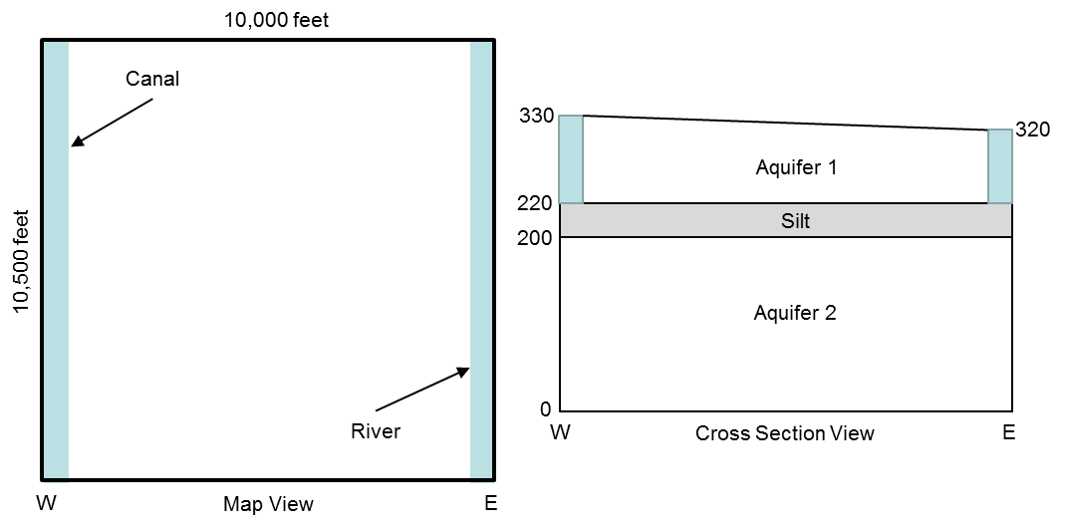

Exercise 1:
Using the water budget summary in the MODFLOW listing file, what is the total volumetric rate of flow leaving the canal and the total volumetric rate of flow entering the river?

For comparison, use Darcy’s Law and the head output in the listing file to compute the total flow rate out of the canal and into the river. Calculate the flow from one canal cell and multiply by 21 rows to get the total flow. To simplify your calculations, use the average saturated thickness between columns 1 and 2 for the horizontal flow calculation. For the vertical flow calculation, assume that all of the head difference between the canal and the node in layer 2 occurs within the confining layer between the bottom of layer 1 and the node in layer 2. How do these flow rates compare with those determined from the MODFLOW water budget summary?

Exercise 2:
Between which two columns does the flow between layer 1 and layer 2 change from downward to upward?

Exercise 3:
What are the total volumetric rates of flow from column 10 to column 11 in each of the three model layers. Use Darcy’s Law and the head output from the MODFLOW listing file to make these calculations.

 | h₁₀ | h₁₁ | Δh  (h₁₁ – h₁₀₎ | b  layer thickness | Q  (all 21 rows)
Layer 1
Layer 2
Layer 3

